**SUMMER INTERNSHIP PROJECT REPORT**

on

**“MOVIE RECOMMENDATION SYSTEM”**

*Using K- Nearest Neighbors (K-NN) Algorithm*

*submitted in the partial fulfillment of the requirement for the award of the degree of*

***Bachelor of Technology***

***In***

***Artificial Intelligence and Machine Learning***

Submitted by:

ANSH BHARTI

Enrollment No.: A501132522004

Under the guidance of

Dr. Shweta Sinha

**ASET, Amity University Haryana**



Department of Computer Science and Engineering

Amity School of Engineering & Technology

Amity University, Haryana Gurugram, India

26th September 2024

 **Department of Computer Science and Engineering**

**Amity School of Engineering and Technology**

### DECLARATION

I, Ansh Bharti, Student of Bachelor of Technology in Department of Computer Science and Engineering, Amity School of Engineering and Technology, Amity University Haryana, hereby declare that I am fully responsible for the information and results provided in this project report titled *“Movie Recommendation System”* submitted to Department of Computer Science and Engineering, Amity School of Engineering and Technology, Amity University Haryana, Gurgaon for the partial fulfilment of the requirement for the award of the degree of *Bachelor of Technology in Artificial Intelligence and Machine Learning* . I have taken care in all respects to honor intellectual property rights and have acknowledged the contributions of others for using them. I further declare that in case of any violation of intellectual property rights or copyrights, we as a team would be fully responsible for the same. My supervisor, Head of department and the Institute should not be held for full or partial violation of copyrights if found at any stage of my degree.

Date: September 2024 Ansh Bharti

 **Department of Computer Science and Engineering**

**Amity School of Engineering and Technology**

### CERTIFICATE

This is to certify that the work in the project report entitled “Movie Recommendation System” by Ansh Bharti bearing Enroll. No. A501132522004 is a bona fide record of project work carried out by her under my supervision and guidance in Summer Internship Program of Bachelor of Technology in Computer Science and Engineering in the Department of Computer Science and Engineering, Amity School of Engineering and Technology, Amity University Haryana, Gurgaon. Neither this project nor any part of it, has been submitted for any degree or academic award elsewhere.

Date: 24th September 2024

Signature of Supervisor

(Dr. SHEWTA SINHA)

Associate Professor

Computer Science & Engineering

ASET, Amity University, Haryana

**INTERNSHIP CERTIFICATE**

**ACKNOWLEDGEMENT**

I wish to express my deepest gratitude for the successful completion of this Movie Recommendation System Project, which was made possible through the unwavering support, encouragement, and guidance of several remarkable individuals. First and foremost, I extend my heartfelt thanks to Dr. Shweta Sinha, Associate Professor at ASET, Amity University Haryana. His expertise in python, machine learning algorithms has been invaluable, and his mentorship provided me with the direction and confidence needed to tackle the challenges of this project. I am also profoundly grateful to my family for their steadfast support and encouragement. Their belief in my abilities and patience during the demanding periods of development were instrumental in achieving this goal. Additionally, I wish to acknowledge the contributions of my friends and peers. Their enthusiasm, insightful feedback, and collaborative spirit were crucial in refining and enhancing the chatbot's functionality. Each discussion and piece of advice played a significant role in shaping the outcome. In conclusion, I want to thank everyone who has supported and contributed to this project. Your presence and encouragement have been a source of immense strength and inspiration, and I am deeply appreciative of the collective effort that has led to the successful realization of this Movie Recommendation system Project

**ABSTRACT**

### The development of a personalized movie recommendation system represents a pivotal innovation in how users discover and engage with entertainment. With the ever-growing availability of films, selecting the right movie can be overwhelming. This system addresses that challenge by providing tailored movie suggestions based on individual preferences and viewing history. By employing collaborative filtering, content-based filtering, and a hybrid recommendation model, it delivers highly relevant recommendations that align closely with the user’s tastes, enhancing the overall viewing experience.

### The algorithm which the model is working is the k-Nearest Neighbours (KNN) algorithm, which calculates similarity between users or movies to make recommendations. KNN operates by identifying users with similar movie ratings or preferences and suggests movies that these users have highly rated. This collaborative filtering approach ensures personalized recommendations by analysing patterns in user behaviour. In addition, content-based filtering is implemented by analysing movie features like genres, enhancing the recommendation system’s ability to suggest films that resonate with a user’s past preferences. The combination of these approaches ensures a robust and well-rounded recommendation experience.

### To improve user interaction, the system is built with a user-friendly interface using Streamlit, allowing users to input their preferences and choose different recommendation methods, whether user-based or genre-based. By integrating machine learning algorithms and updating dynamically with new data, the system remains responsive to users’ evolving tastes. This movie recommendation system, therefore, not only provides accurate and relevant suggestions but also ensures that users can explore and discover films that suit their preferences more effectively.

**LIST OF FIGURES**

|  |  |  |
| --- | --- | --- |
| **FIGURE** | **CAPTION** | **PAGE NO.** |
| *Figure 4.1.1* | *Architecture Overview* | *17ß* |
| *Figure (5.1.1)* | *Implementation of recommendations using User-based filtering* | *19* |
| *Figure (5.1.2)* | *Implementation of recommendations using Genre-based filtering* | *19* |
| *Figure (5.1.3)* | *Implementation of recommendations using User and Genre based filtering* | *19* |
| *Figure (5.1.4)* | *Implementation of front end using Streamlit* | *20* |
| *Figure (5.2.1)* | *Out look of front-end* | *21* |
| *Figure (5.2.2)* | *Recommendation Methods* | *21* |
| *Figure (5.2.3)* | *Result of recommendations using User-based filtering* | *22* |
| *Figure (5.2.4)* | *Result of recommendations using Genre-based filtering* | *23* |
| *Figure (5.2.5)* | *Result of recommendations using both (User-based and Genre-based filtering)* | *24* |

**TABLE OF CONTENTS**

|  |  |
| --- | --- |
| DECLARATION | i |
| CERTIFICATE | ii |
| INTERNSHIP CERTIFICATE | iii |
| ACKNOWLEDGEMENT | iv |
| ABSTRACT | v |
| LIST OF FIGURES | vi |
| CHAPTER 1 INTRODUCTION | 8-9 |
| 1.1  Movie Recommendation System | 8 |
| 1.2  The Aim Of Movie Recommendation System | 8 |
| 1.3  The Need For Personalized Movie Recommendation | 8 |
| 1.4  The Role Technology In Movie Recommendation | 9 |
| 1.5  Objectives | 9 |
| CHAPTER 2 BACKGROUND STUDY | 10-12 |
| 2.1  Historical Evolution Of Movie Recommendation | 10 |
| 2.2  Challenges Facing Contemporary Film Discovery | 10 |
| 2.3  Rise Of Algorithmic Recommendation | 11 |
| 2.4  Functionality of Movie Recommendation System | 11 |
| 2.5  Rationale For Developing The Movie  Recommendation System | 12 |
| CHAPTER 3 - TECHNOLOGY USED | 13-14 |
| 3.1  Data Acquisition Layer | 13 |
| 3.2  Feature Extraction | 13 |
| 3.3   Recommendation Algorithms | 13 |
| 3.4   Machine Learning Models | 14 |
| 3.5   Recommendation Engine | 14 |
| 3.6   User Interface And Interaction Layer | 14 |
| 3.7   Performance And Optimization | 14 |
| CHAPTER 4 – METHODOLOGIES AND DESIGN OF THE PROJECT | 15-18 |
| 4.1 Methodologies | 15-16 |
| 4.2 System Design | 17-18 |
| CHAPTER 5 - IMPLEMENTATION AND RESULTS | 19-23 |
| 5.1 Implementation | 19-21 |
| 5.2 RESULT & Proof of Concept (PoC) | 22-25 |
| CHAPTER 6 - CONCLUSION AND FUTURE SCOPE | 26 |
| 6.1 Conclusion | 26 |
| 6.2 Future Scope | 26 |
| REFRENCES | 27 |

**CHAPTER 1**

**INTRODUCTION**

**1.1 Movie Recommendation System (MRS)**

A movie recommendation system (MRS) is designed to assist users in navigating vast libraries of available films by offering personalized suggestions. By analyzing a user’s past interactions, ratings, and preferences, the system identifies patterns and relationships within the data to suggest movies that the user is likely to enjoy. There are various techniques used in building such systems, including collaborative filtering, content-based filtering, and hybrid approaches that combine both methods. These systems are widely used by streaming platforms to enhance user experience by providing relevant movie options that align with individual tastes and viewing habits

**1.2 Aim of the Movie Recommendation System**

The primary aim of the movie recommendation system is to simplify the movie selection process by delivering personalized suggestions to users. Given the overwhelming number of movies available, users often find it difficult to choose what to watch. The recommendation system alleviates this challenge by tailoring its suggestions based on a combination of user behavior and movie features. By doing so, it enables users to discover films that match their preferences, increasing engagement and satisfaction with the platform.

**1.2 The Need for Personalized Movie Recommendations**

**1.2.1 Growing Variety of Content**

The rise of streaming platforms has led to an explosion of available content, with thousands of movies being released each year. Users are often left with an overwhelming number of choices, which makes it difficult to find movies they will enjoy. This recommendation system addresses the challenge of content discovery by offering tailored movie suggestions, helping users navigate through extensive catalogues efficiently.

**1.2.2 The Limitations of Traditional Search Methods**

Traditional methods of searching for movies based on title, genre, or popularity often fall short of delivering personalized results. Users may miss out on lesser-known films that match their preferences. A recommendation system, on the other hand, bypasses these limitations by learning from user interactions and movie features to suggest films that would likely resonate with the user, even if they haven't been explicitly searched for

**1.3. The Role of Technology in Movie Recommendations**

**1.3.1 Collaborative and Content-Based Filtering**

This system employs two primary techniques: collaborative filtering and content-based filtering. Collaborative filtering relies on user behaviour, drawing insights from user ratings and preferences to recommend movies that other similar users have enjoyed. On the other hand, content-based filtering analyses the characteristics of movies—such as genres, directors, and actors—to suggest films with similar attributes to those a user has previously liked. By combining both techniques, the system offers a more holistic approach to personalization.

**1.3.2 Hybrid Approach for Enhanced Accuracy**

A hybrid recommendation system that incorporates both user-based and content-based methods ensures higher accuracy and relevance in the recommendations. By blending user behaviour with movie metadata, the system is able to provide more precise recommendations, factoring in not only what users have liked in the past but also the specific attributes that define their movie preferences.

**1.4 Objectives**

**1.4.1 Improving Movie Discovery**

The goal of this project is to create a recommendation system that simplifies the process of discovering new movies. By offering tailored recommendations based on user interactions and movie attributes, the system aims to improve the user experience and foster better engagement with the content libraries.

**1.4.2 Enhancing User Satisfaction Through Personalization**

By leveraging machine learning algorithms such as k-Nearest Neighbours (KNN), this system is designed to deliver movie suggestions that are more closely aligned with the individual preferences of users. This personalized approach increases the likelihood of user satisfaction, as the recommendations will be based on data-driven insights into both user behaviour and movie content.

**CHAPTER 2**

**BACKGROUND STUDY**

The development of a movie recommendation system (MRS) represents a crucial advancement in enhancing user experiences within the ever-expanding landscape of digital entertainment. Understanding the context and rationale behind the creation of this system involves examining several key aspects.

**2.1 Historical Evolution of Movie Recommendations**

Historically, the way audiences discovered films has undergone significant transformation. Initially, movie recommendations relied on word-of-mouth, critical reviews, and genre categorizations. With the advent of cable television and video rental stores, curated lists and expert recommendations became popular. The rise of the internet, particularly streaming services, ushered in a new era where algorithms began to play a critical role in suggesting films based on user preferences. These early recommendation systems paved the way for the sophisticated methods we see today.

**2.2 Challenges Facing Contemporary Film Discovery**

Despite the advancements in technology, users still face a number of challenges when it comes to discovering films:

- Information Overload: With an overwhelming number of movies available across numerous platforms, users often struggle to find content that suits their tastes, leading to decision fatigue.

- Diversity of Content: The proliferation of genres, sub-genres, and independent films complicates the search process. Users may miss out on films that align with their preferences simply due to the sheer volume of choices.

- Static Search Methods: Traditional search methods, which often rely on metadata or popularity rankings, do not necessarily cater to individual preferences. This can result in a lack of personalization in the user experience.

**2.3 Rise of Algorithmic Recommendations**

In response to these challenges, algorithmic recommendation systems have emerged as transformative tools for movie discovery. These systems leverage various technologies and methodologies, including:

- Collaborative Filtering: This technique analyzes user behavior and preferences to identify patterns and suggest movies based on what similar users have enjoyed.

- Content-Based Filtering: This method focuses on the attributes of the movies themselves, such as genres, directors, and actors, to recommend similar films to those a user has previously liked.

- Hybrid Approaches: By combining collaborative and content-based filtering, hybrid systems can offer more nuanced and personalized recommendations, taking into account both user interactions and movie features

**2.4 Functionality of the Movie Recommendation System**

The Movie Recommendation System (MRS) is a sophisticated tool developed to streamline the process of film discovery in an era characterized by an overwhelming abundance of content. The MRS leverages machine learning techniques, particularly collaborative filtering and content-based filtering, to offer personalized movie recommendations tailored to the specific preferences of users. By analysing historical user interactions, such as ratings and viewing habits, along with various attributes of movies—such as genres, actors, and directors—the system generates suggestions that align closely with user interests. This dual approach not only improves the accuracy of the recommendations but also enhances user satisfaction, making it easier for individuals to find films they are likely to enjoy in an extensive digital library.

**2.5 Rationale for Developing the Movie Recommendation System**

The development of the MRS is driven by the need to address the limitations of traditional film discovery methods and improve user satisfaction in the digital entertainment landscape. By leveraging advanced recommendation algorithms, the MRS offers several potential benefits:

- Personalized Recommendations: By analyzing user behavior and preferences, the system provides tailored movie suggestions, enhancing the likelihood of user satisfaction and engagement.

- Efficient Content Discovery: The MRS simplifies the process of finding relevant films, allowing users to spend less time searching and more time enjoying content.

- Dynamic Learning: As users interact with the system, it continuously learns from their preferences and feedback, refining its recommendations over time to better serve their tastes.

In conclusion, the movie recommendation system stands as a significant advancement in addressing the challenges of film discovery in today’s digital age, aiming to provide a more personalized and efficient way for users to explore the vast array of cinematic offerings.

**CHAPTER 3**

**TECHNOLOGY USED**

**3.1 Data Acquisition Layer**

**3.1.1 User Interaction Data**

The system collects data from users based on their movie ratings, viewing history, and interactions with the platform. This data serves as the foundation for generating personalized recommendations.

**3.1.2 Movie Metadata**

Detailed information about each movie, such as genres, directors, actors, and release dates, is gathered. This metadata helps the system better understand user preferences and make relevant suggestions.

**3.1.3 External Data Sources**

Additional data, such as trending movies or critical reviews, can be incorporated to enhance the system’s recommendations by considering popular and well-received films.

**3.2 Feature Extraction**

The system extracts relevant features from both user data and movie metadata. These features include user-specific information like viewing patterns and movie-specific elements like genre and cast. This extraction process helps in identifying patterns and similarities between users and movies.

**3.3.Recommendation Algorithms**

**3.3.1 Collaborative Filtering**

The recommendation system leverages collaborative filtering techniques, which analyse the behaviour of users with similar preferences. This method is effective in suggesting movies that other users with similar tastes have enjoyed.

**3.3.2 Content-Based Filtering**

In addition to collaborative filtering, content-based filtering is applied to recommend movies that are similar to ones a user has previously liked. This approach focuses on analysing the attributes of films such as genres, directors, and themes.

**3.3.3 Hybrid Models**

A combination of collaborative and content-based filtering techniques is used to create a hybrid recommendation model. This allows for more accurate and comprehensive suggestions by utilizing the strengths of both approaches.

**3.4 Machine Learning Models**

**3.4.1 K-Nearest Neighbours (KNN)**

The system employs the KNN algorithm to identify movies that are most similar to the user’s past preferences. By finding the “nearest” neighbours in terms of user similarity or movie attributes, the system provides relevant recommendations.

**3.4.2 Matrix Factorization**

Matrix factorization techniques, such as Singular Value Decomposition (SVD), are used to analyse and reduce the complexity of large datasets, enabling the system to make accurate recommendations even with sparse data.

**3.5 Recommendation Engine**

The core of the system is the recommendation engine, which processes the extracted features and applies algorithms to generate personalized movie recommendations. The engine updates and improves as it gathers more user interaction data, ensuring the recommendations become more accurate over time.

**3.6 User Interface and Interaction Layer**

**3.6.1 Graphical Interface**

The system provides an intuitive user interface where users can easily rate movies, view recommendations, and explore suggested films based on their preferences.

**3.6.2 Search and Filter Options**

Users can actively search for movies and apply filters like genre, release year, or rating, allowing them to find content tailored to their mood or preferences.

**3.7 Performance and Optimization**

The system employs optimization techniques to ensure that the recommendations are not only accurate but also generated in a timely manner, even when processing large amounts of data. This includes optimizing query performance and ensuring that algorithms run efficiently.

By integrating these technologies, the movie recommendation system is able to provide users with a personalized and dynamic movie-watching experience, catering to their individual tastes and preferences over time.

CHAPTER 4

METHODOLOGIES AND DESIGN OF THE PROJECT

**4.1 System Design**

**4.1.1 Architecture Overview**

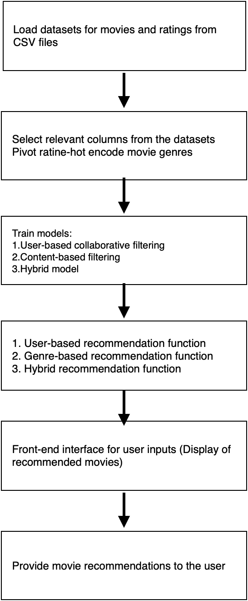

*Figure 4.1.1 : Architecture Overvie*

The Movie Recommendation System (MRS) is designed with a modular architecture, ensuring that various components work together seamlessly to deliver recommendations:

* Data Acquisition Layer: This layer is responsible for gathering user interaction data (ratings, views) and movie metadata (genres, actors, directors) from multiple sources.
* Recommendation Engine Layer: This layer applies collaborative filtering, content-based filtering, and hybrid models to generate movie recommendations.
* Model Evaluation Layer: It evaluates the accuracy of the system using error metrics like MSE and RMSE to improve the recommendations over time.
* User Interface Layer: The system presents the recommendations through an intuitive, user-friendly interface that supports rating, viewing, and exploring suggested movies.

**4.1.2 Component Design**

* Data Collection Component: Includes modules for gathering user data (ratings, reviews) and movie data (genres, actors, release dates). This data serves as the foundation for the recommendation process.
* Preprocessing Component: Handles data cleaning, normalizing, and structuring to ensure that it is ready for analysis by the recommendation algorithms.
* Recommendation Engine Component: Implements collaborative filtering (user-based and item-based) and content-based filtering to generate personalized movie recommendations. Hybrid models may also be used to combine the strengths of both filtering techniques.
* Evaluation Component: Analyses the accuracy of the recommendations using performance metrics such as MSE and RMSE, ensuring continuous improvement of the model.
* User Interface Component: Provides the front-end interface for users to interact with the recommendation system, allowing them to view, rate, and explore movie suggestions.

**4.2 Methodologies Used**

**4.2.1 Data Collection and Preprocessing**

* **Data Input:** Movie and user rating datasets are imported from CSV files, which provide the necessary raw data for the recommendation system.
* **Data Preprocessing:**
* The datasets are filtered to select only the relevant columns, such as movieId, title, genres (for movies), and userId, movieId, rating (for ratings).
* A **user-item matrix** is generated by pivoting the ratings data to have movies as rows and users as columns. Missing ratings are filled with zero.
* **One-hot encoding** is applied to movie genres to create a genre matrix, which captures content-based features for each movie. This genre matrix is then combined with the user-item matrix to create a hybrid data structure.

**4.2.2 Collaborative Filtering**

* **User-Based Collaborative Filtering:**
* A **K-Nearest Neighbours (KNN)** algorithm is trained on the user-item matrix to find movies that users with similar preferences have rated highly.
* The similarity between users is computed using cosine distance, identifying movies enjoyed by similar users for personalized recommendations.

**4.2.3 Content-Based Filtering**

* A content-based filtering model is trained using the genre matrix. The model identifies movies with similar genre attributes to the ones a user has liked in the past.
* **KNN** is applied to the genre matrix, where movies are recommended based on similarity in genre, independent of user ratings.

**4.2.4 Hybrid Approach**

* A **hybrid model** combines user-based and content-based filtering by using both the user-item matrix and the genre matrix in the recommendation engine.
* This model takes advantage of both collaborative filtering (based on user preferences) and content-based filtering (based on movie features like genre) to provide more accurate and diverse recommendations.

**4.2.5 Model Training and Evaluation**

* **Model Training:** The system trains three different models:
* A **user-based collaborative filtering** model.
* A **content-based filtering** model.
* A **hybrid model** combining both approaches.
* **Evaluation Metrics:** The performance of these models can be evaluated using metrics such as **Mean Squared Error (MSE)** and **Root Mean Squared Error (RMSE)** to measure the accuracy of the recommendations. These metrics help assess how well the system predicts user ratings and movie preferences.

**4.2.6 User Interaction and Real-Time Updates**

* The front-end provides an interface where users can input their preferences (select a movie, choose a recommendation method) and view recommended movies. Users can choose between:
* **User-based filtering.**
* **Genre-based filtering.**
* **Hybrid filtering (both user-based and genre).**
* **Real-time updates** occur as users interact with the system, continuously refining the recommendation engine to reflect the latest user preferences and interactions.

CHAPTER – 5

IMPLEMENTATION AND RESULT

**5.1 Implementation of the Movie Recommendation System**

**5.1.1 Data Preprocessing and Feature Engineering**

The first step in implementing the Movie Recommendation System involves data preprocessing, which is crucial for ensuring the quality and reliability of recommendations. This process includes cleaning the dataset by handling missing values, removing duplicates, and normalizing the data. Feature engineering is also applied to extract relevant attributes, such as genres, directors, and user ratings, to create a comprehensive user-movie interaction matrix. One-hot encoding is utilized for categorical variables like genres, allowing the model to effectively analyse movie features and user preferences. This step lays the groundwork for accurate recommendation generation.

**5.1.2 Model Development and Training**

Following data preprocessing, the next phase focuses on the development and training of the recommendation models. The system primarily employs collaborative filtering and content-based filtering techniques. Collaborative filtering uses algorithms like k-Nearest Neighbours (KNN) to find similarities between users and recommend movies based on the preferences of similar users. Content-based filtering analyses the features of movies that a user has previously enjoyed to suggest similar titles. These models are trained on historical user interaction data, allowing them to learn patterns and improve their accuracy over time.

**5.1.3 User Interface and Experience**

To facilitate user interaction, a user-friendly interface is developed using Streamlit. This interface allows users to input their preferences, view recommendations, and rate movies easily. The design prioritizes simplicity and accessibility, ensuring that users can navigate the system intuitively. Additionally, the interface provides options for users to choose different recommendation strategies, such as collaborative or content-based filtering. Continuous user feedback is incorporated to refine the system further, enhancing the overall user experience and engagement with the movie recommendation process.

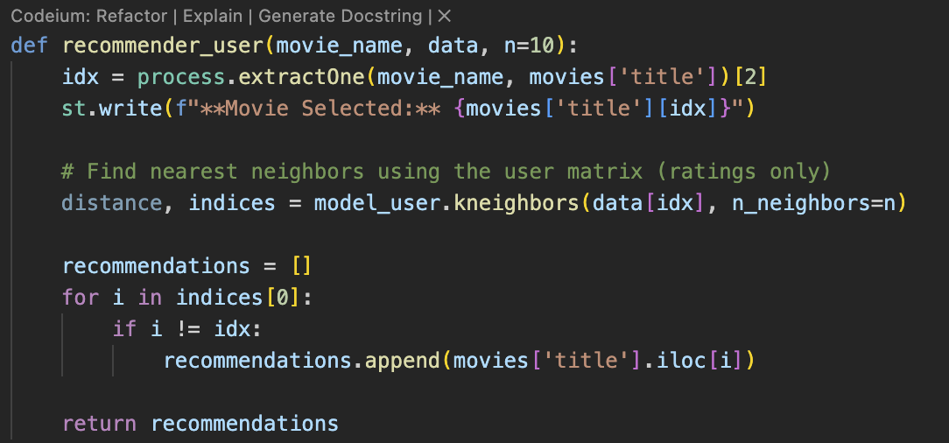

*Figure (5.1.1) : Implementation of recommendations using User-based filtering*

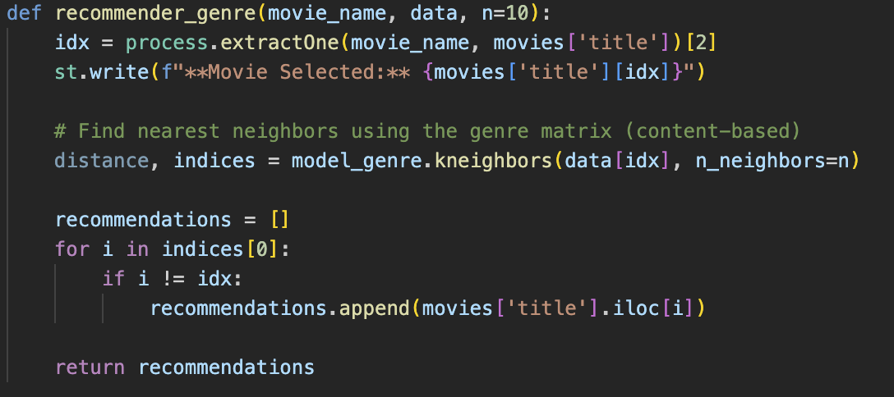

*Figure (5.1.2) : Implementation of recommendations using Genre-based filtering*

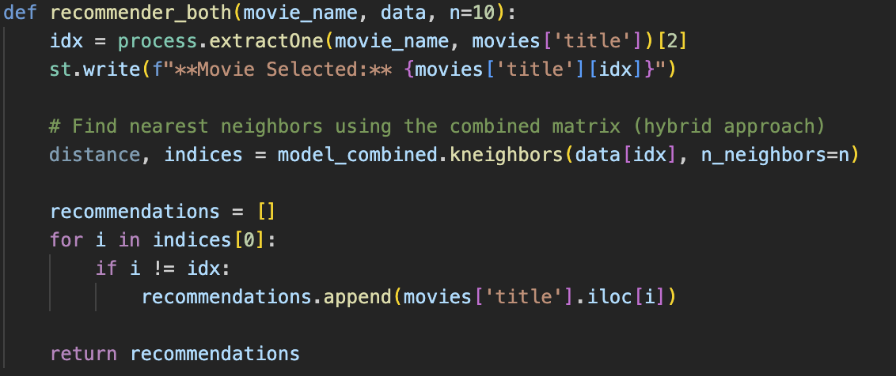

*Figure (5.1.3) : Implementation of recommendations using User and Genre based filtering*

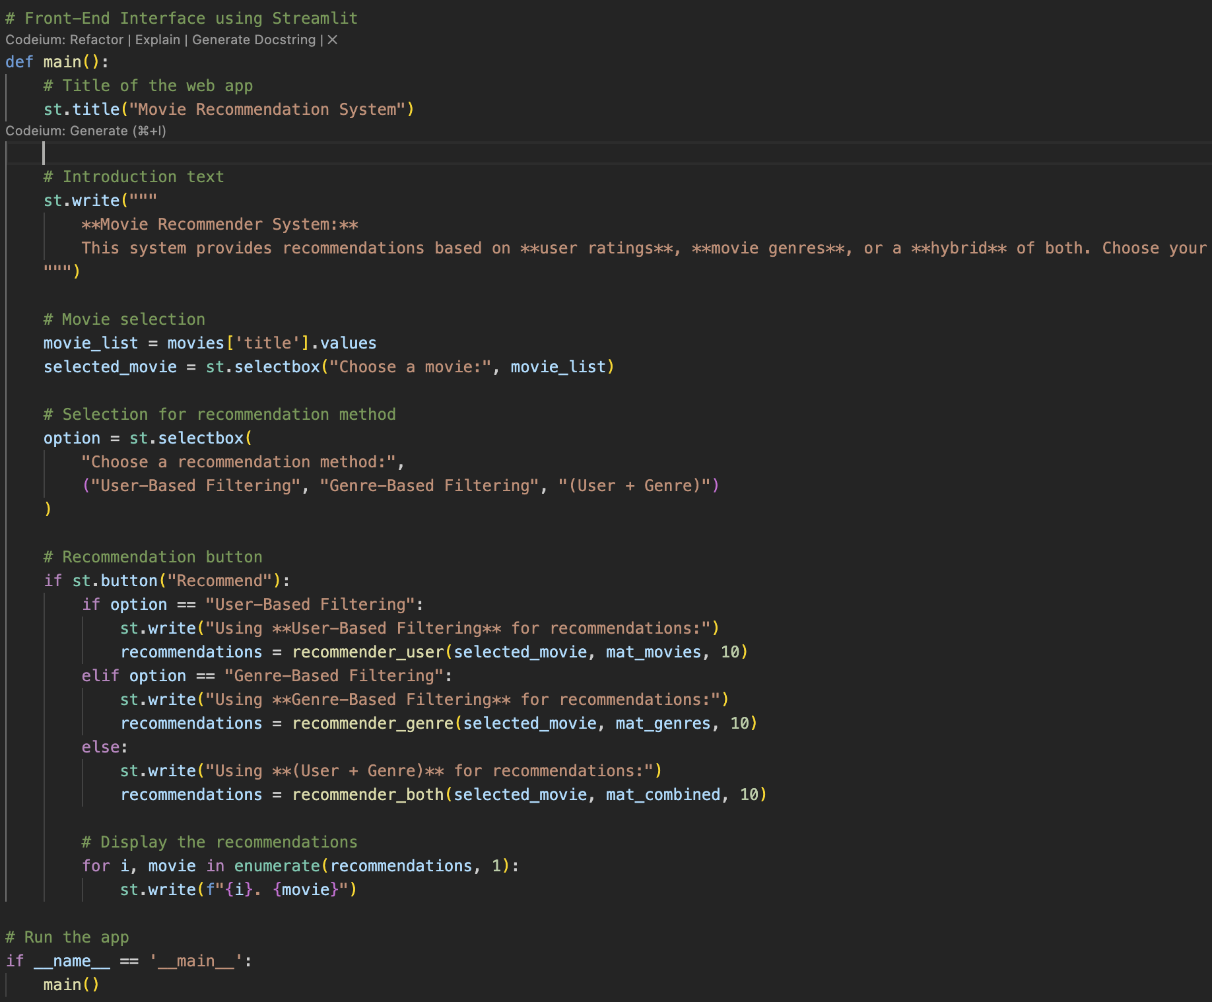

*Figure (5.1.4) : Implementation of front end using Streamlit*

**5.2 RESULT & Proof of Concept (PoC)**

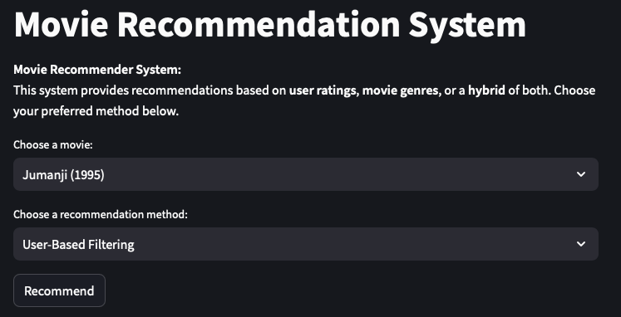

*Figure (5.2.1): Out look of front-end*

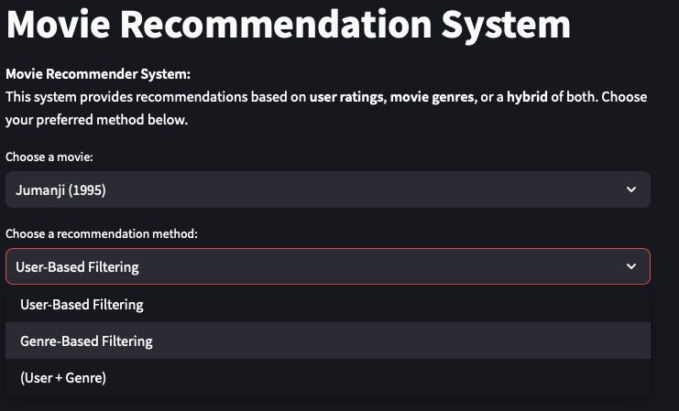

*Figure (5.2.2) : Recommendation Methods*

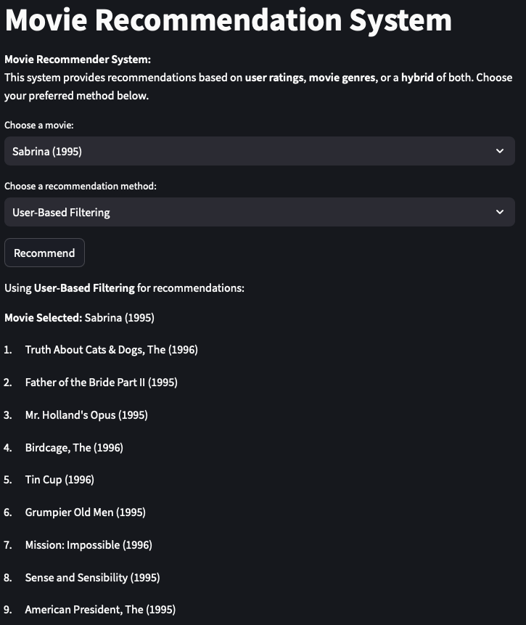

*Figure (5.2.3) : Result of recommendations using User-based filtering*

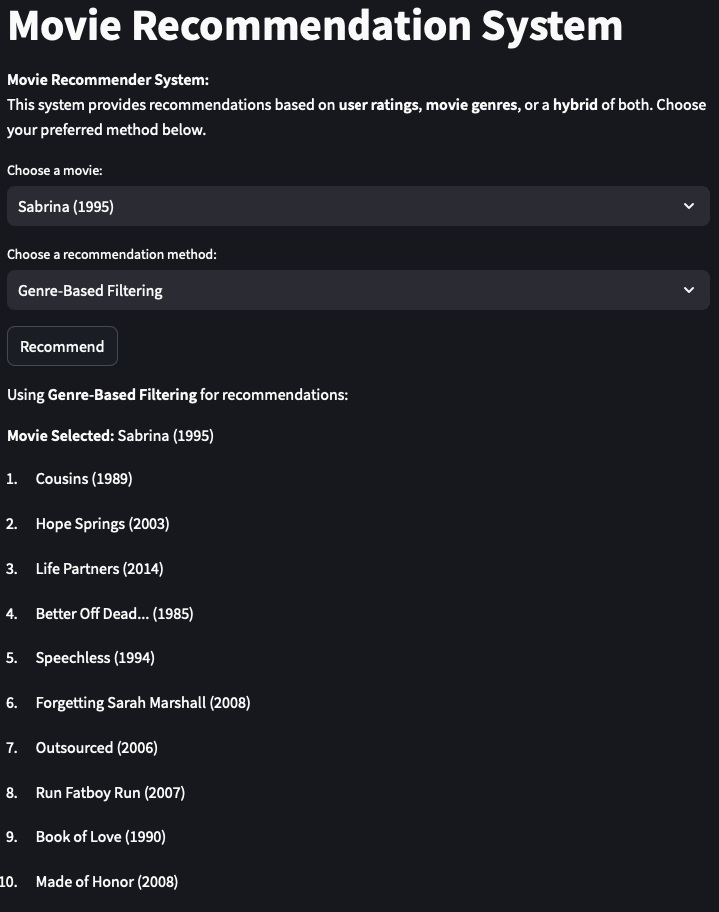

*Figure (5.2.4) : Result of recommendations using Genre-based filtering*

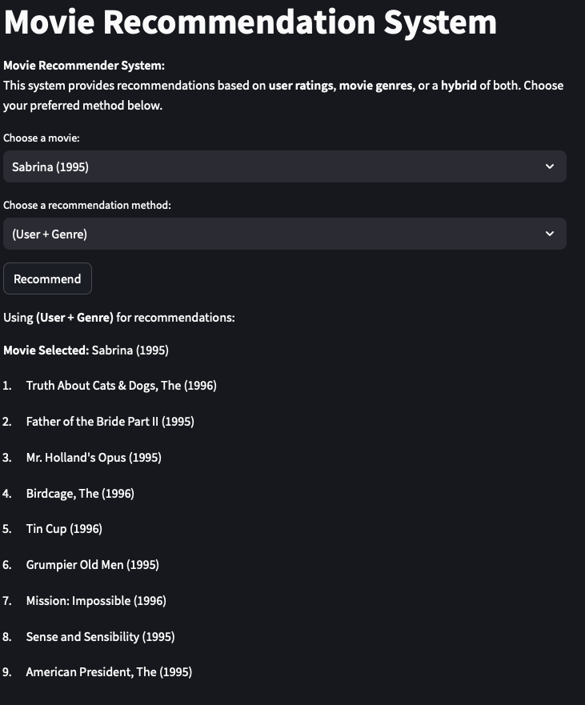

*Figure (5.2.5) : Result of recommendations using both (User-based and Genre-based filtering)*

**CHAPTER – 6**

**CONCLUSION AND FUTURE SCOPE**

**6.1 CONCLUSION**

In conclusion, the development of the Movie Recommendation System (MRS) successfully demonstrates how data-driven algorithms, such as collaborative and content-based filtering, can be applied to personalize user experiences. By leveraging movie ratings and preferences, the system offers tailored suggestions that enhance user engagement and satisfaction. The MRS provides a scalable and efficient solution for navigating large movie libraries, helping users discover films that align with their tastes.

**6.2 FUTURE SCOPE**

1. Advanced Model Integration: Explore the use of deep learning and hybrid recommendation systems to improve recommendation accuracy and capture complex user preferences.
2. Real-Time Data Updates: Implement real-time feedback systems where user actions, like new ratings or watches, instantly refine and update recommendations.
3. Enhanced Scalability: Leverage cloud-based infrastructure to handle growing datasets and increasing user demand without sacrificing system performance.
4. Improved User Experience: Incorporate user feedback to refine the interface and make the system more intuitive and accessible for diverse audiences.
5. Cross-Platform Accessibility: Develop mobile applications for iOS and Android, allowing users to access personalized movie recommendations across multiple devices.
6. Integration with Streaming Platforms: Partner with popular streaming services to offer direct watch options, providing seamless transitions from recommendation to viewing.
7. Social Integration: Enable social sharing of movie recommendations and viewing habits, allowing users to engage with friends and discover movies based on peer suggestions.
8. Personalized Notifications: Implement a notification system that informs users about new releases, trending movies, or films based on their viewing history and preferences.

**REFERENCES**

**Academic Papers**

1. S. A. A. Shah, A. M. Khan, A. B. Anwar, and S. M. Ali, “A Survey on Recommendation Systems: From Traditional to Deep Learning,” *IEEE Access*, vol. 8, pp. 24542-24561, 2020.
2. Y. Koren, “Collaborative Filtering with Temporal Dynamics,” *Communications of the ACM*, vol. 53, no. 4, pp. 89-97, 2010.
3. J. Bobadilla, F. Ortega, A. Hernando, and A. Gutiérrez, “Recommender Systems Survey,” *Knowledge-Based Systems*, vol. 46, pp. 109-132, 2013.

**Books**

1. R. Burke, “Hybrid Recommender Systems: Survey and Experiments,” in *User Modelling 2002*, pp. 206-216.
2. J. Ben Schafer, J. Konstan, and John Riedl, “E-commerce recommendation applications,” in *Recommender Systems: Challenges and Opportunities*, New York: Springer, 2009, pp. 183-203.
3. Online Resources
4. “Movie Recommendation System using Collaborative Filtering,” Towards Data Science, 2020. [Link](https://towardsdatascience.com/movie-recommendation-system-using-collaborative-filtering-3a0b1a89e6e0)
5. “How Netflix Works: The Math Behind the Movies,” Medium, 2021. [Link](https://medium.com/swlh/how-netflix-works-the-math-behind-the-movies-4e43f5c428d4)
6. “Building a Movie Recommendation System in Python,” DataCamp. [Link](https://www.datacamp.com/community/tutorials/building-recommendation-system-python)

**Additional Resources**

1. “Introduction to Recommender Systems,” Coursera (Course). [Link](https://www.coursera.org/learn/recommender-systems)
2. “The MovieLens Dataset,” GroupLens Research. [Link](https://grouplens.org/datasets/movielens/)